Home task

Author: **Ilana M**., mail: [ilana.imelnik.melnik@gmail.com](mailto:ilana.imelnik.melnik@gmail.com), phone: 0546880847

Date: 07.03.2020

Script name: **matcher.py**

Script purpose: Script will search file/s, for match by regex expression, given by the user in command line argument.

Used external libraries:

# to work with command line arguments

import argparse

import sys

# to parse test by regex

import re

# work with files

import os.path

# to highlight the printed text

from colorama import init

from termcolor import colored

I divided the functionality of the script into two phases

First I get the command line arguments from the user by calling method :

command_line_arguments = read_command_line_arguments()

I check the correctness of the regex

I check that there are files to search in

I build a list of files that later will be checked for match

With all this info I initiate object of the class:

RegMatcher

That knows to check each file to find match

This object calls class method:

check_files_by_regex()

Each file in a list is being opened, I check if match is found in each line then according to the user preference (command line arguments) I sign the match with either color or underline or starting location of the found match.

Tests:

Several test were performed, such as:

Playing with inexistense of optional or mandatory arguments, or with combination of optional arguments.

Supplying no files in command line argument or supplying empty list  
  
supplying file name in STDIN with quit sign or supplying empty list of files via STDIN

Testing different regexes

Straight forward tests with legal regex and test file that potentially has matches and checking that starting position is correct, or coloring / underlining the correct match. Same tests but with several files

You can run the script with already defined script args this way:

Go to

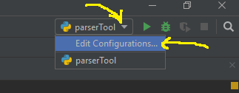

Then in the opened window define

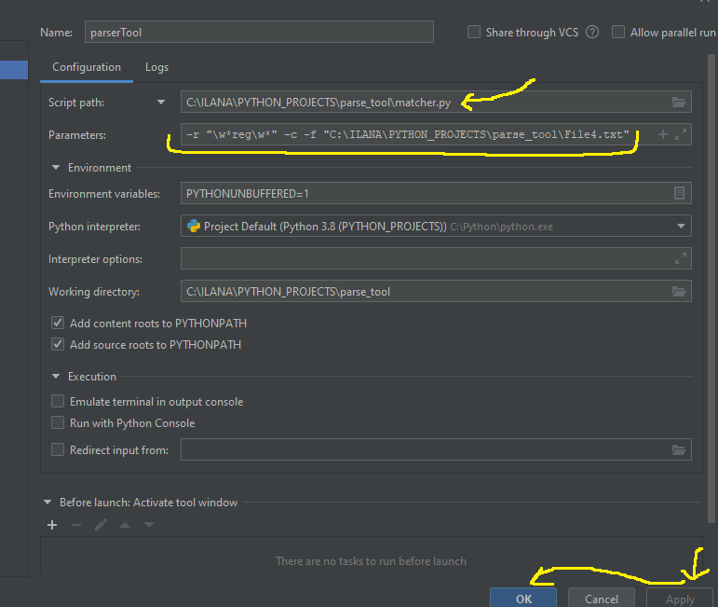

The script name: matcher.py

Parameters: here you see –r followed by regex expression, -c to sign the match. –f followed with path to the file/s, click on “**Apply**” then click on “**OK**”